Ground Truth (0)

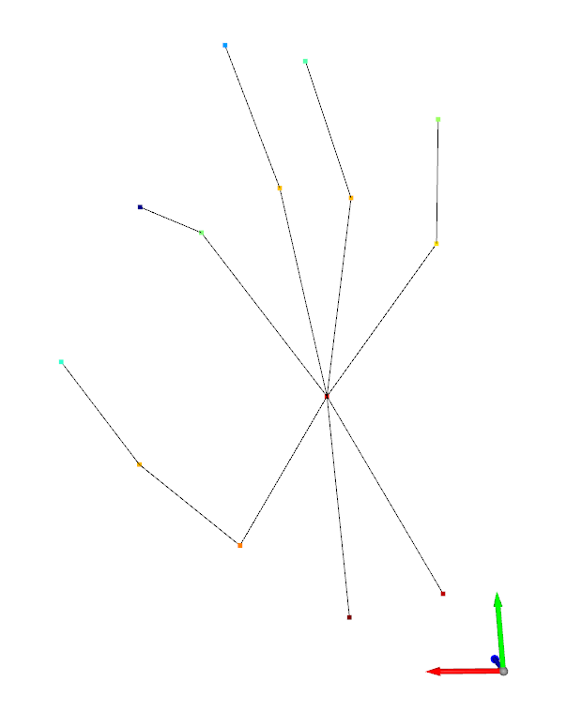

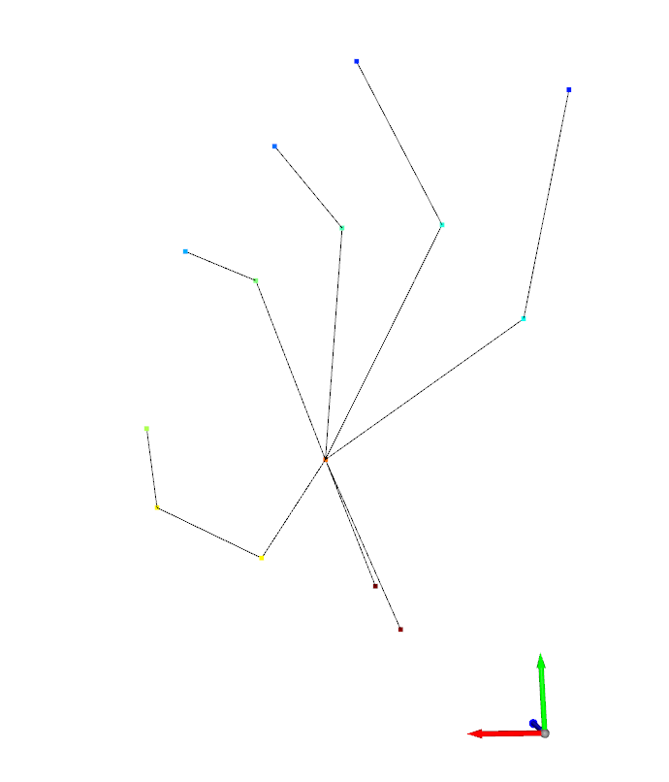Predictiction (0)

Ground Truth (1)

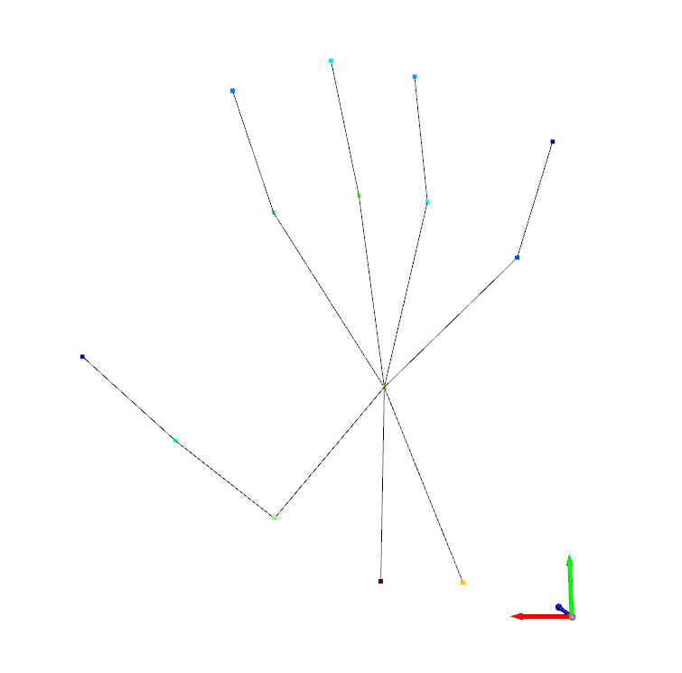

Prediction (1)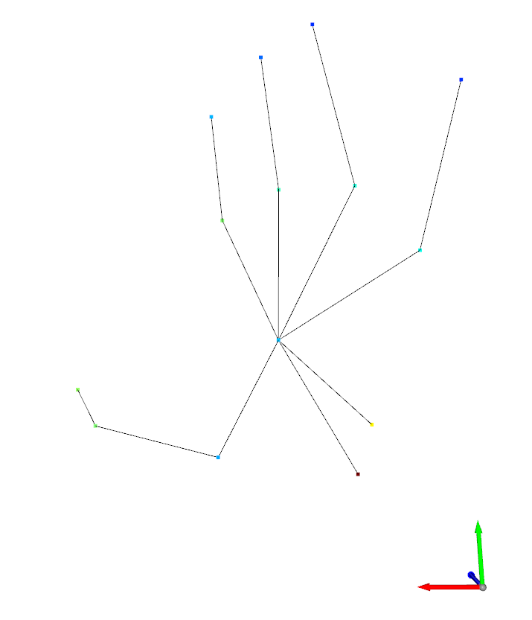

Ground Truth (2)

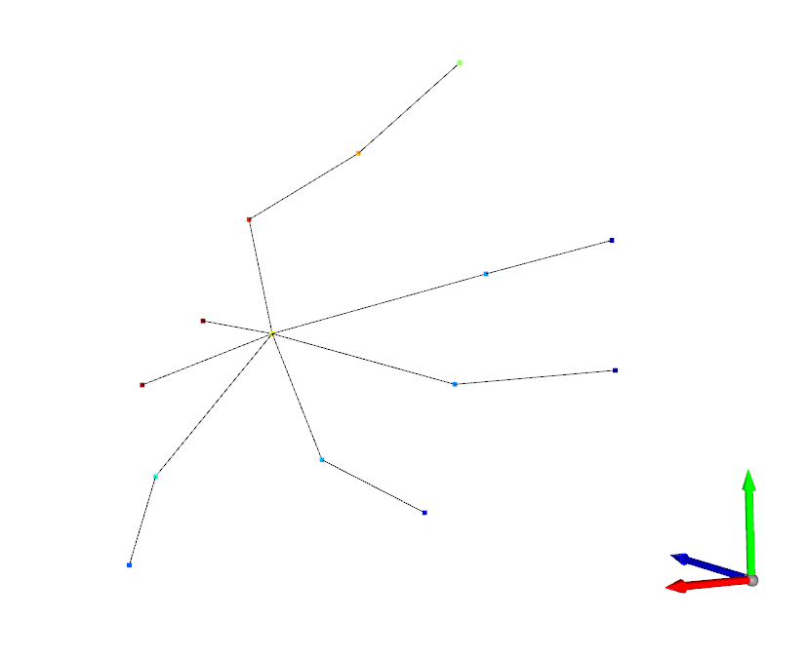

Prediction (2)

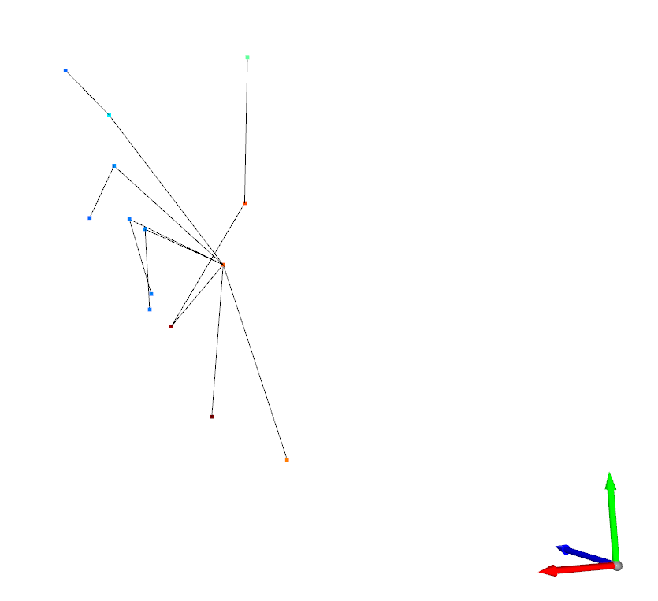

Ground Truth (3)

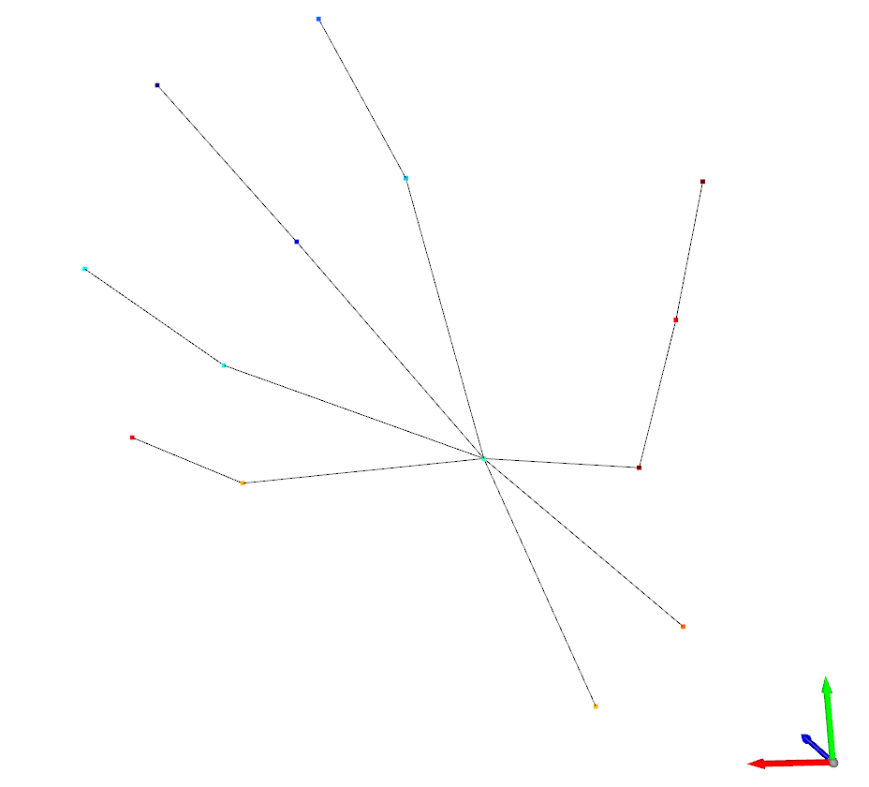

Prediction (3)

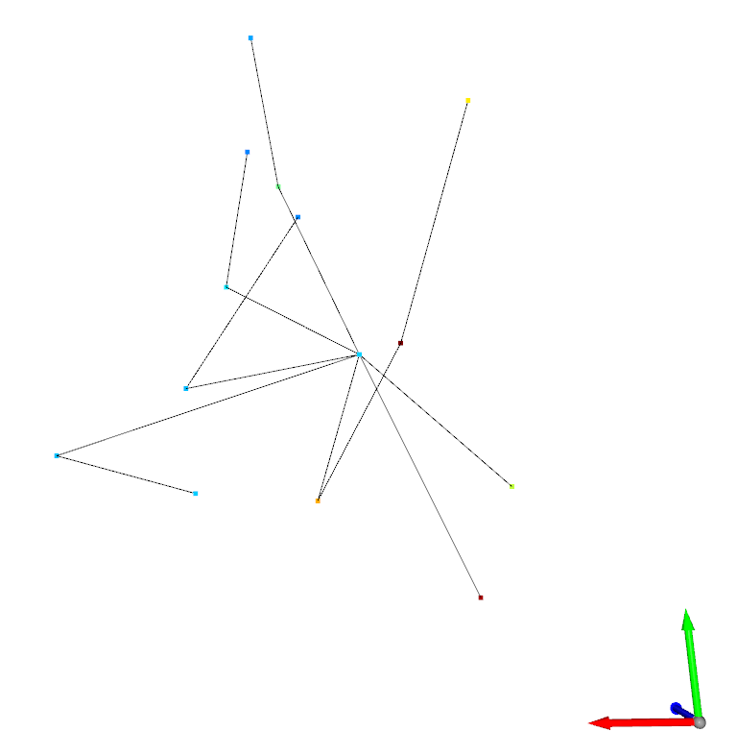

Ground Truth (4)

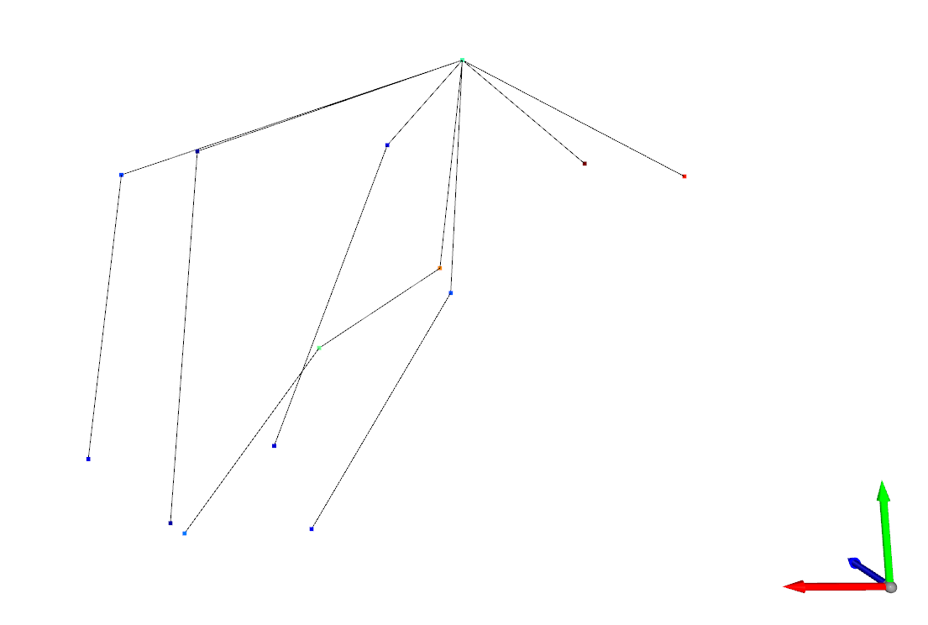

Prediction (4)

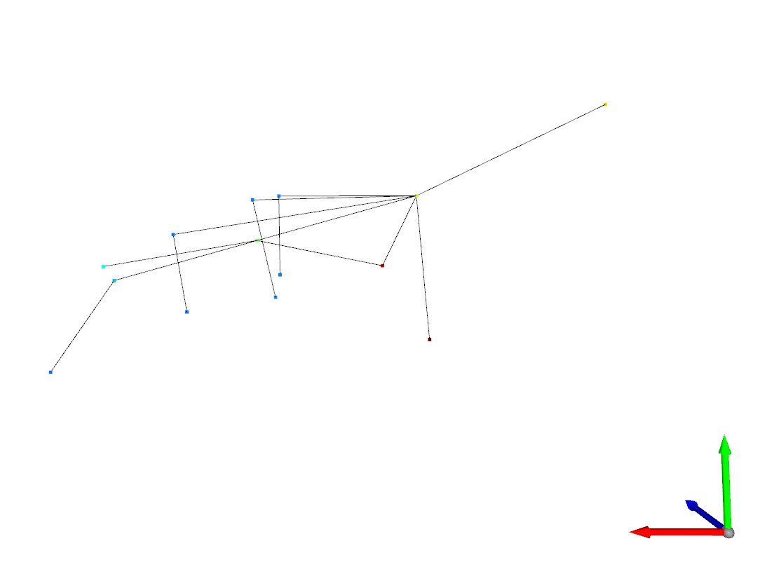

Network Loss:

[1, 3500] loss: 0.003

Average_validation_loss was=0.00319782474807774

[2, 3500] loss: 0.002

Average_validation_loss was=0.002472843981192758

[3, 3500] loss: 0.002

Average_validation_loss was=0.0026606883228135606

[4, 3500] loss: 0.002

Average_validation_loss was=0.0019318944981011252

[5, 3500] loss: 0.002

Average_validation_loss was=0.0018336254723059634

[6, 3500] loss: 0.002

Average_validation_loss was=0.0018685027654282748

[7, 3500] loss: 0.002

Average_validation_loss was=0.0018659125131865342

[8, 3500] loss: 0.002

Average_validation_loss was=0.002296881186310202

[9, 3500] loss: 0.002

Average_validation_loss was=0.0019218439888209105

[10, 3500] loss: 0.001

Average_validation_loss was=0.0012247292827814817

[11, 3500] loss: 0.001

Average_validation_loss was=0.001219381003640592

[12, 3500] loss: 0.001s

Average_validation_loss was=0.0011867708581266925

[13, 3500] loss: 0.001

Average_validation_loss was=0.0011660290924677004

[14, 3500] loss: 0.001

Average_validation_loss was=0.0012149673129509514

[15, 3500] loss: 0.001

Average_validation_loss was=0.001222839109793616